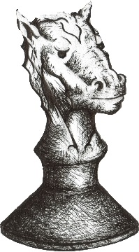

2023
Mountain Scholastic Chess
Tournament for Children

When: Saturday October 14 9:00 AM -- + 2:30 PM (Sign-in 8:30 – 9:00)

Where: Rim of the World High School, 27400 CA-18, Lake Arrowhead, CA 92352

Who: K through 12th grade players who know the fundamentals of the game

Divisions: Students will be in Swiss sections based upon grade level and previous
tournament results.

Rules: A Swiss style, touch-move tournament with a time control of Game 15.

Awards: 1st, 2nd, 3rd place trophies will be awarded in each division

Registration: The tournament is FREE to those who register by Thursday, Oct. 12th
$10 registration at the door. Please be on site by 8:30 to check-in
and register.

Contact: Keith Martin at: rimhighchess@gmail.com or (C) 775.560.8600

The posting or distribution of written materials by students does not indicate District endorsement of the content of the materials or of the organization, group, company, agency, or individuals associated with the materials.

Snacks and lunch for sale at tournament or bring your own.
______________________________________________________________

Tournament Registration:
email information to Keith Martin at: rimhighchess@gmail.com

Student Name ___________________________________ Grade _______________

School ____________________________________ City ___________________

Contact & Phone _________________ ( ) __________ e-mail _________________

Parent/guardian signature below indicates permission to participate in the Rim High School Scholastic Chess Tournament and to allow RYCA and RHS to post tournament pictures online.

Parent/guardian permission ______________________________________________

