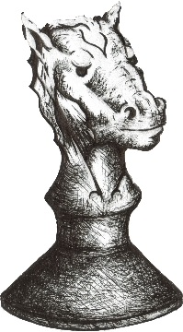
CHESS RUMBLE ON THE RIM

2019-2020
Rim High School
Scholastic Chess Tournament

When: Saturday November 16th 9:15 AM -- + 2:30 PM (Sign-in 8:30 – 9:00)

Where: Rim of the World High School, 27400 CA-18, Lake Arrowhead, CA 92352
In the school cafeteria, entrance is on the north side of CA-18

Who: K through 12th grade players who know the fundamentals of the game

Divisions: + 9 divisions with some grade levels combined in a Round Robin format.
Note: Swiss System pairings may be used in the HS sections in the
event of a large enrollment. Clocks will be used for grades 6-12 with a
time control of 20 minutes for each player (Game/20 or G/20).

Awards: 1st, 2nd, 3rd place trophies will be awarded in each division

Registration: The tournament is FREE to those who register by Thursday, November 14th or $10 registration at the door. ALL arrivals after 9:00 will have to pay a $10 late fee. Please be on site by 8:30 to check-in/register and no later than 9:00 am!

Contact: Keith Martin at: island19@aol.com or (C) 775.560.8600

Directions, maps, etc., are also available at: https://www.facebook.com/RimHighChess

Snacks and lunch for sale at tournament or bring your own
_____________________________________________________________________

Tournament Registration: email information to Keith Martin at: island19@aol.com

Student Name ___________________________________ Grade _______________

School ____________________________________ City ___________________

Contact & Phone _________________ ( ) __________ e-mail _________________

Parent/guardian signature below indicates permission to participate in the Rim High School Scholastic Chess Tournament and to allow RYCA and RHS to post tournament pictures on our website or Facebook pages.

Parent/guardian permission ______________________________________________

