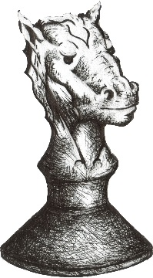
CHESS RUMBLE ON THE RIM

2022
Rim High School
Scholastic Chess Tournament

When: Saturday March 12th 9:00 AM -- + 2:30 PM (Sign-in 8:30 – 9:00)

Where: Rim of the World High School, 27400 CA-18, Lake Arrowhead, CA 92352

Who: K through 12th grade players who know the fundamentals of the game

Divisions: + 6 divisions with some grade levels combined in a Round Robin format
Note: Swiss System pairings may be used in the HS sections in the
event of a large enrollment. Grades 6-12 may be using clocks for timed
games.

Awards: 1st, 2nd, 3rd place trophies will be awarded in each division

Registration: The tournament is FREE to those who register by Thursday, March 10th
$10 registration at the door. Please be on site by 8:30 to check-in/register

Contact: Keith Martin at: (C) 775.560.8600 or email to: rimhighchess@gmail.com

Directions, maps, etc., are also available at: https://www.facebook.com/RimHighChess

The posting or distribution of written materials by students does not indicate District endorsement of the content of the materials or of the organization, group, company, agency, or individuals associated with the materials.

Snacks and lunch for sale at tournament or bring your own
_____________________________________________________________________

Tournament Registration: email information to Keith Martin at: rimhighchess@gmail.com

Student Name ___________________________________ Grade _______________

School ____________________________________ City ___________________

Contact & Phone _________________ ( ) __________ e-mail _________________

Parent/guardian signature below indicates permission to participate in the Rim High School Scholastic Chess Tournament and to allow RYCA and RHS to post tournament pictures on our website or Facebook pages
Parent/guardian permission ______________________________________________

